**[15] Design Turing Machine For Input AnBn**

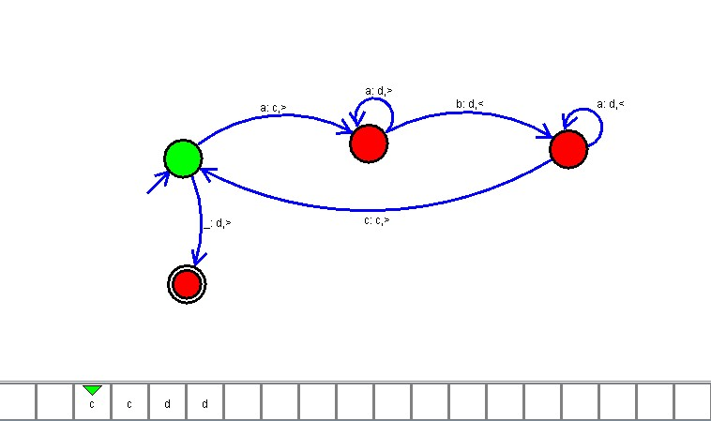

**Result**

The TM is designed to compute the given strings as input using AutoSim tool